**FINAL REPORT**

**Capstone Project - The Battle of Neighbourhoods week 1 and week 2**

**Introduction:**

* The people of Indian origins are spread all over the world and have been working away from their motherland in search of a better future and good pay. One such group being the ones living in the US, achieving their American dreams. Although many amongst are not really choosy about food, if there is a restaurant in the vicinity they do not really hesitate to go the distance, after all, each Indian is a foodie and New York is pretty diverse.
* With its diverse culture, comes diverse food items. There are many restaurants in New York City, each belonging to different categories like Chinese, Indian, and French etc.
* so as a project I will try to make a good story out of this situation about Indians in US hungry for some native food.

**Problem:**

To find the answers to the following questions:

Q1) List and visualize all major parts of New York City that has great Indian restaurants.

Q2) what is best location in New York City for Indian Cuisine?

Q3) which areas have potential Indian Restaurant Market?

Q4) which all areas lack Indian Restaurants?

Q5) which is the best place to stay if you prefer Indian Cuisine?

**Data Section:**

For this project we need the following data:

* For this project we need the following data:

1. New York City data that contains list Boroughs, Neighborhoods along with their latitude and longitude.(Data source : <https://cocl.us/new_york_dataset>)

2. Indian resturants in each neighborhood of new york city. (Data source : Foursquare API)

3. GeoSpace data ([https://data.cityofnewyork.us/City-Government/Borough-oundaries/tqmj-8zm](https://data.cityofnewyork.us/City-Government/Borough-Boundaries/tqmj-j8zm))

**Methodology:**

1. We begin by collecting the New York city data from the following link "[https://cocl.us/new_york_dataset"](https://cocl.us/new_york_dataset%22)

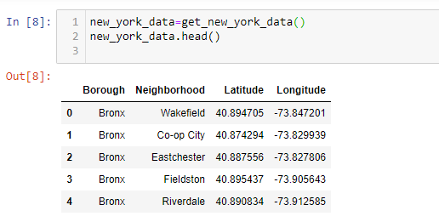

1. We will find all venues for each neighbourhood using Foursquare API

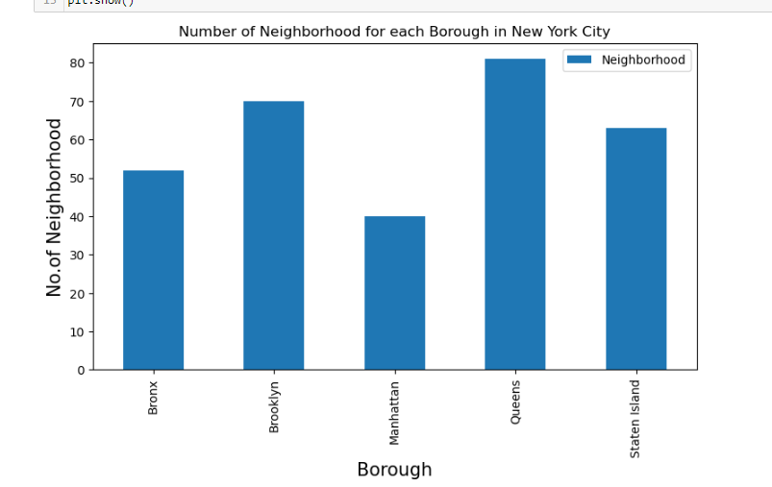

1. We will then filter out all venues with Indian restaurant for further analysis.

1. Next using Foursquare API, we will find the Ratings, Tips, and Number of Likes for all the Indian Restaurants.

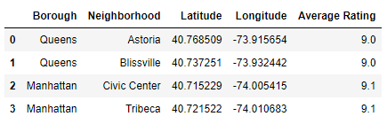

1. We will then sort Neighbourhoods and Borough the data keeping Ratings as the constraint.
2. Next we will consider all the neighbourhoods with average rating greater or equal 9.0 to visualize on map.

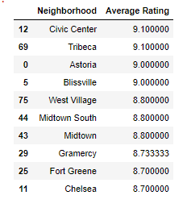

1. We will join this dataset to original New York data to get longitude and latitude.



1. Finally, we will visualize the Neighbourhoods and Borough based on average Rating using python’s Folium library.

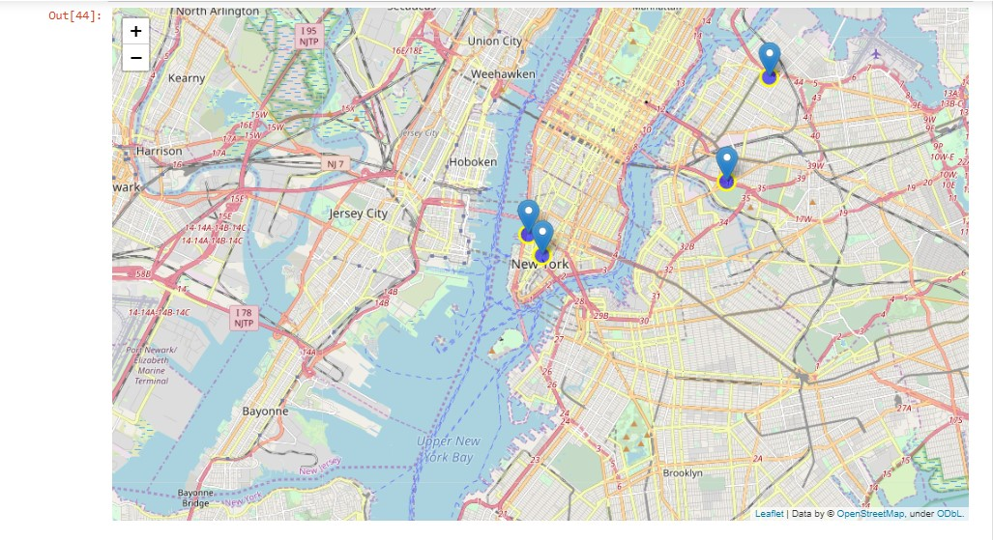Neighbourhoods based on average rating:

Borough based on average rating:

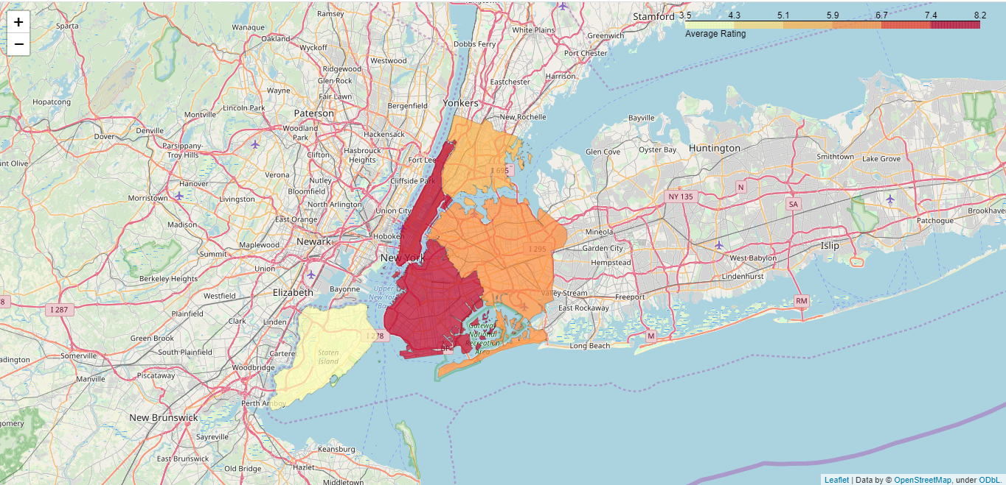

**Result:**

So now we can answer the questions asked above in the Questions section:

Answers:

1. The following location in New York City has great Indian restaurants.



#### Astoria (Queens), Blissville (Queens), Civic Center (Manhattan) are some of the best neighbourhoods for Indian cuisine.

#### Manhattan have potential Indian Restaurant Market.

#### Staten Island ranks last in average rating of Indian Restaurants.

#### Manhattan is the best place to stay if you prefer Indian Cuisine.

**Conclusion:**

There is always room for improvement and hence the above solution I have provided can also be improved for best results depending upon the data we have.